**CTF Challenge: Hacking Mobile Platform**



**Hacking Mobile Platform?**

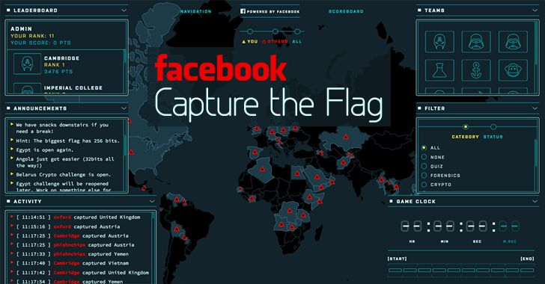

Hacking mobile platforms involves exploiting vulnerabilities in mobile devices (such as smartphones and tablets) and their operating systems (like iOS or Android) to gain unauthorized access, steal data, or perform malicious actions. Here are some key points about hacking mobile platforms:

### **Common Techniques for Hacking Mobile Platforms**

1. **Operating System Exploits**: Exploiting vulnerabilities in the mobile operating system (OS) to gain root or administrative access.
2. **Application Layer Exploits**: Exploiting vulnerabilities in mobile applications to gain unauthorized access or escalate privileges.
3. **Man-in-the-Middle (MitM) Attacks**: Intercepting and manipulating data sent between the mobile device and external servers.
4. **Phishing**: Sending fraudulent messages or apps to trick users into revealing sensitive information, such as login credentials or financial details.
5. **Bluetooth and Wi-Fi Attacks**: Exploiting vulnerabilities in wireless communication protocols to gain access to devices or intercept data.
6. **Social Engineering**: Manipulating users into performing actions that compromise their device's security, such as installing malicious apps or clicking on malicious links.

### **Tools for Hacking Mobile Platforms**

* **Metasploit**: A penetration testing framework that includes modules for exploiting vulnerabilities in mobile devices and applications.
* **DroidJack**: A remote administration tool (RAT) for Android devices that allows attackers to control infected devices remotely.
* **Burp Suite**: A comprehensive tool for web application security testing that can be used to test the security of mobile apps.
* **Frida**: A dynamic instrumentation toolkit for developers, reverse engineers, and security researchers, used to hook into and modify application behavior on the fly.
* **Xposed Framework**: A framework for modules that can change the behavior of the system and apps without touching any APKs.

# **Capture the Flag (CTF) Challenges**

Flag 1. Which penetration testing framework includes modules for exploiting vulnerabilities in mobile devices and applications?

Answer: Metasploit

Flag Captured

Flag 2. What type of attack involves intercepting and manipulating data sent between a mobile device and external servers?

Answer: Man-in-the-Middle (MitM) Attack

Flag Captured

Flag 3. Which tool is used to dynamically hook into and modify application behavior on Android devices?

Answer: Frida

Flag Captured

Flag 4. What is the name of the framework for modules that can change the behavior of the system and apps on Android devices?

Answer: Xposed Framework

Flag Captured

Flag 5. What security measure should users employ to protect sensitive data stored on their mobile devices from unauthorized access?

Answer: Encryption

Flag Captured